R Code

#Installing Packages#

```{r}

install.packages("rstatix")

library(tidyr)

library(rstatix)

library(ggplot2)

library(dplyr)

library(ggpubr)

```

#Quick Descriptive Statistics#

```{r}

hist(TAPPIT_Final$T1_Mindfulness)

hist(TAPPIT_Final$T3_Mindfulness)

hist(TAPPIT_Final$T7_Mindfulness)

```

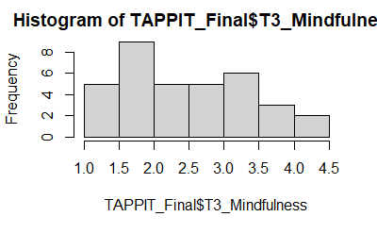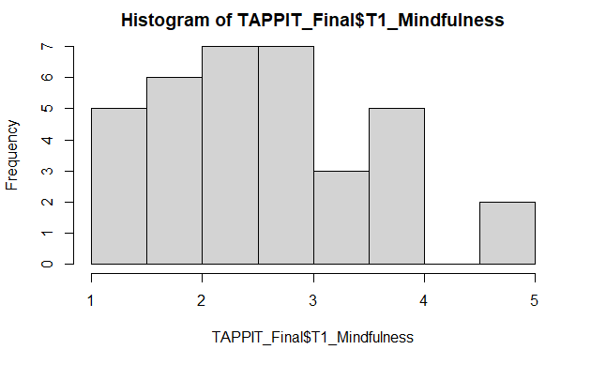

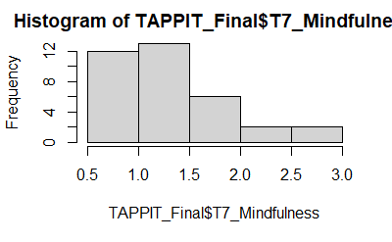

#Selecting Columns#

```{r}

df1 <- dplyr::select(TAPPIT_Final,ID,T1_Mindfulness,T3_Mindfulness,T7_Mindfulness)

```

#Relabelling Columns#

```{r}

names(df1)[names(df1) == "T1_Mindfulness"] <- "Day 1"

names(df1)[names(df1) == "T3_Mindfulness"] <- "Day 3"

names(df1)[names(df1) == "T7_Mindfulness"] <- "Day 7"

```

#Reversing scores for Mindfulness#

```{r}

df1$`Day 1` <- 5-df1$`Day 1`

df1$`Day 3` <- 5-df1$`Day 3`

df1$`Day 7` <- 5-df1$`Day 7`

```

#Pivoting Columns#

```{r}

dfLong <- pivot_longer(df1,cols=c("Day 1","Day 3","Day 7"),names_to="Timepoints",values_to="Mindfulness")

```

#Summary Statistics#

```{r}

dfLong %>%

group_by(Timepoints) %>%

get_summary_stats(Mindfulness, type = "mean_sd")

```

Timepoints variable n mean sd

Day 1 Mindfulness 35 2.354 0.969

Day 3 Mindfulness 35 2.491 0.937

Day 7 Mindfulness 35 3.674 0.564

#Boxplot#

```{r}

boxplot(Mindfulness~Timepoints, data=dfLong)

```

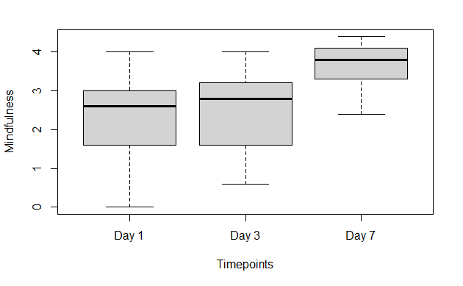

#ANOVA#

```{r}

model1 <- anova_test(data = dfLong, dv = Mindfulness, wid = ID, within = Timepoints)

get_anova_table(model1)

model1

```

ANOVA Table (type III tests)

Effect DFn DFd F p p<.05 ges

1 Timepoints 2 68 66.46 1.01e-16* 0.337

ANOVA Table (type III tests)

$ANOVA

      Effect DFn DFd     F        p p<.05   ges

1 Timepoints   2  68 66.46 1.01e-16     * 0.337

$`Mauchly's Test for Sphericity`

      Effect     W     p p<.05

1 Timepoints 0.878 0.118

$`Sphericity Corrections`

      Effect   GGe      DF[GG]    p[GG] p[GG]<.05   HFe      DF[HF]

1 Timepoints 0.892 1.78, 60.62 3.66e-15         * 0.937 1.87, 63.75

     p[HF] p[HF]<.05

1 7.98e-16         *

#Post Hoc Bonferroni#

```{r}

pwc <- dfLong %>%

pairwise_t_test(

Mindfulness ~ Timepoints, paired = TRUE,

p.adjust.method = "bonferroni"

)

pwc

```

.y. Group1 group2 n1 n2 statistic df pp.adj p.adj.     signif

1Mindfulness Day 1 Day 3 80 80 -0.9565402 34 3.46e-01 1.00e+00ns

2Mindfulness Day 1 Day 7 80 80 -10.4311344 34 3.91e-12 1.17e-11****

3Mindfulness Day 3 Day 7 80 80 -11.2868494 34 4.81e-13 1.44e-12****